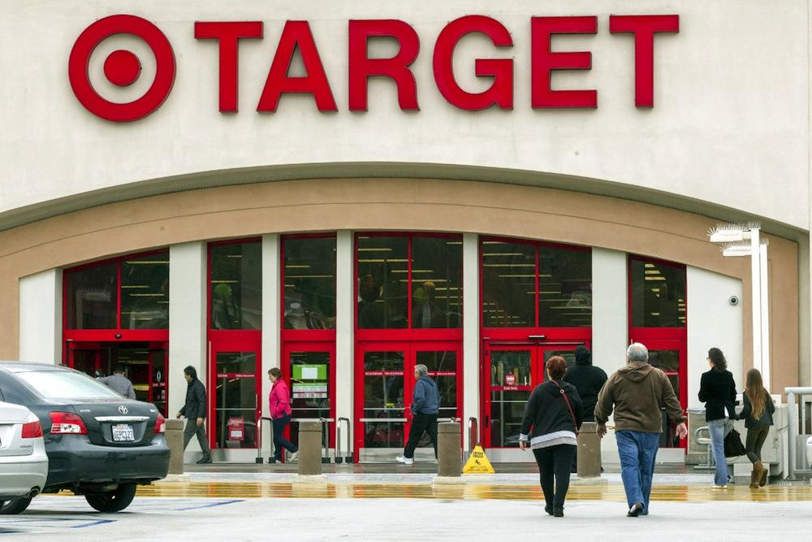

FutureSmart, Module 2: Smart Shopping
Turn Up at Target!

Name: __________________________
Date: ___________________________
Class: _______

Learning Target(s)
I will be able to:
- Use a budget to plan for a party
- Calculate unit price, sales tax, and discounts in a store setting
- Use real-world apps to calculate costs and save money

Celebration Budget Worksheet
Requirements
- Your total budget is $120
- There will be a total of 24 people at your party
- You must purchase at least 1 type of drink for the entire group
- You must purchase at least 2 types of snacks for the entire group
- You must purchase at least 1 fun extra for the party.

Drinks
Item | Amount | Price | Price Per Unit | Better Buy?
Poland Spring Water | ____ bottles | $______ | _________ per quart
Market Pantry Water | _____ bottles | $______ | _________ per quart
Gatorade | _____ bottles | $_______ | _________ per quart
Gatorade | _____ bottles | $______  SALE! $_____ | _________ per quart

Snacks
Item | Amount | Price | Price Per Unit | Better Buy?
12” Red Baron Pepperoni Pizza | _____ slices | $______ | _________ per slice
12” DiGorno Rising Crust Pepperoni Pizza | _____ slices | $_______  SALE! $____ each when you buy __ | _________ per slice
Lay’s Original Chips | 1 ______ oz bag | $______  SALE! ____ for $____ | _________ per pound
UTZ Original Chips | 1 _______ oz bag | $_______  SALE! $______ | _________ per pound
Pringles Variety Pack | _____ count | $________ | _________ per pound
Frito Lay Variety Pack | _____ count | $________  SALE! $_______ | _________ per pound

Snacks continued
Item | Amount | Price | Price Per Unit | Better Buy?
Double Stuf Oreos | _______ count | $_______  SALE! ____ | _________ per pound
Oreos | _______ count | $______  SALE! ____ | _________ per pound
Welch’s Fruit Snacks | _____ packs | $_______ | _________ per pound
Mott’s Fruit Snacks | _____ packs | $_______  SALE! _____ for $______ | _________ per pound

Fun Extras
Item | Amount | Price | Price Per Unit | Better Buy?
Burro Ball Piñata | 1 piñata | $_______ | _________
Unicorn Piñata | 1 piñata | $_______ | _________
Balloons | ______ ct | $_______ | _________ per 100 count
Balloons | ______ ct | $_______ | _________ per 100 count
Child’s Play Standup Pouch | _____ oz | $______  SALE! $______ | _________ per pound
Hershey’s Party Mix Snack Size Assortment | _____ piece  ______ oz | $_______  SALE! $_______ | _________ per pound

Direction: Add up what items you would purchase.
Calculate subtotal, sales tax, and grand total. Use the blank space provided if you need more room or workspace.

DRINKS (Quantity) | ITEM | PRICE
SNACKS (Quantity) | ITEM | PRICE
FUN EXTRA (Quantity) | ITEM | PRICE
 | SUBTOTAL
 | TAX
 | TOTAL

Self Assessment
- How much were you able to save? _______________________________
- On the lines below, explain why you made the purchase choices that you did:
  - ________________________________________________________________________________________________________________________________________________________________________________________________________________________________________________________________________________________
- What was the easiest part of this activity? _______________________________________________________________________________________________________________________________________________________________________________________

- What was the most difficult part of this activity? _______________________________________________________________________________________________________________________________________________________________________________________

- Are there any calculations you still need help with? _______________________________________________________________________________________________________________________________________________________________________________________

- What was your favorite part about this activity? _______________________________________________________________________________________________________________________________________________________________________________________

- What was your least favorite part about this activity? _______________________________________________________________________________________________________________________________________________________________________________________

